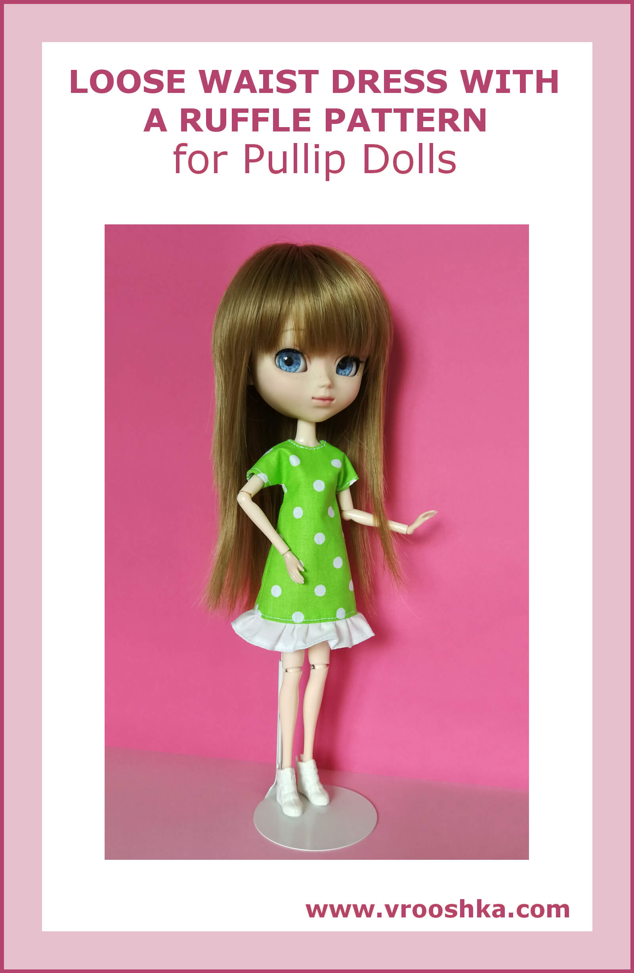
LOOSE WAIST DRESS WITH A RUFFLE

Materials:

a printer, paper, fabric suitable for a dress (one or two colors), a narrow hook and loop fastener or two or three snap fasteners, a tailor’s chalk or a fabric pencil, threads and a needle or a sewing machine, optionally lace or narrow ribbon

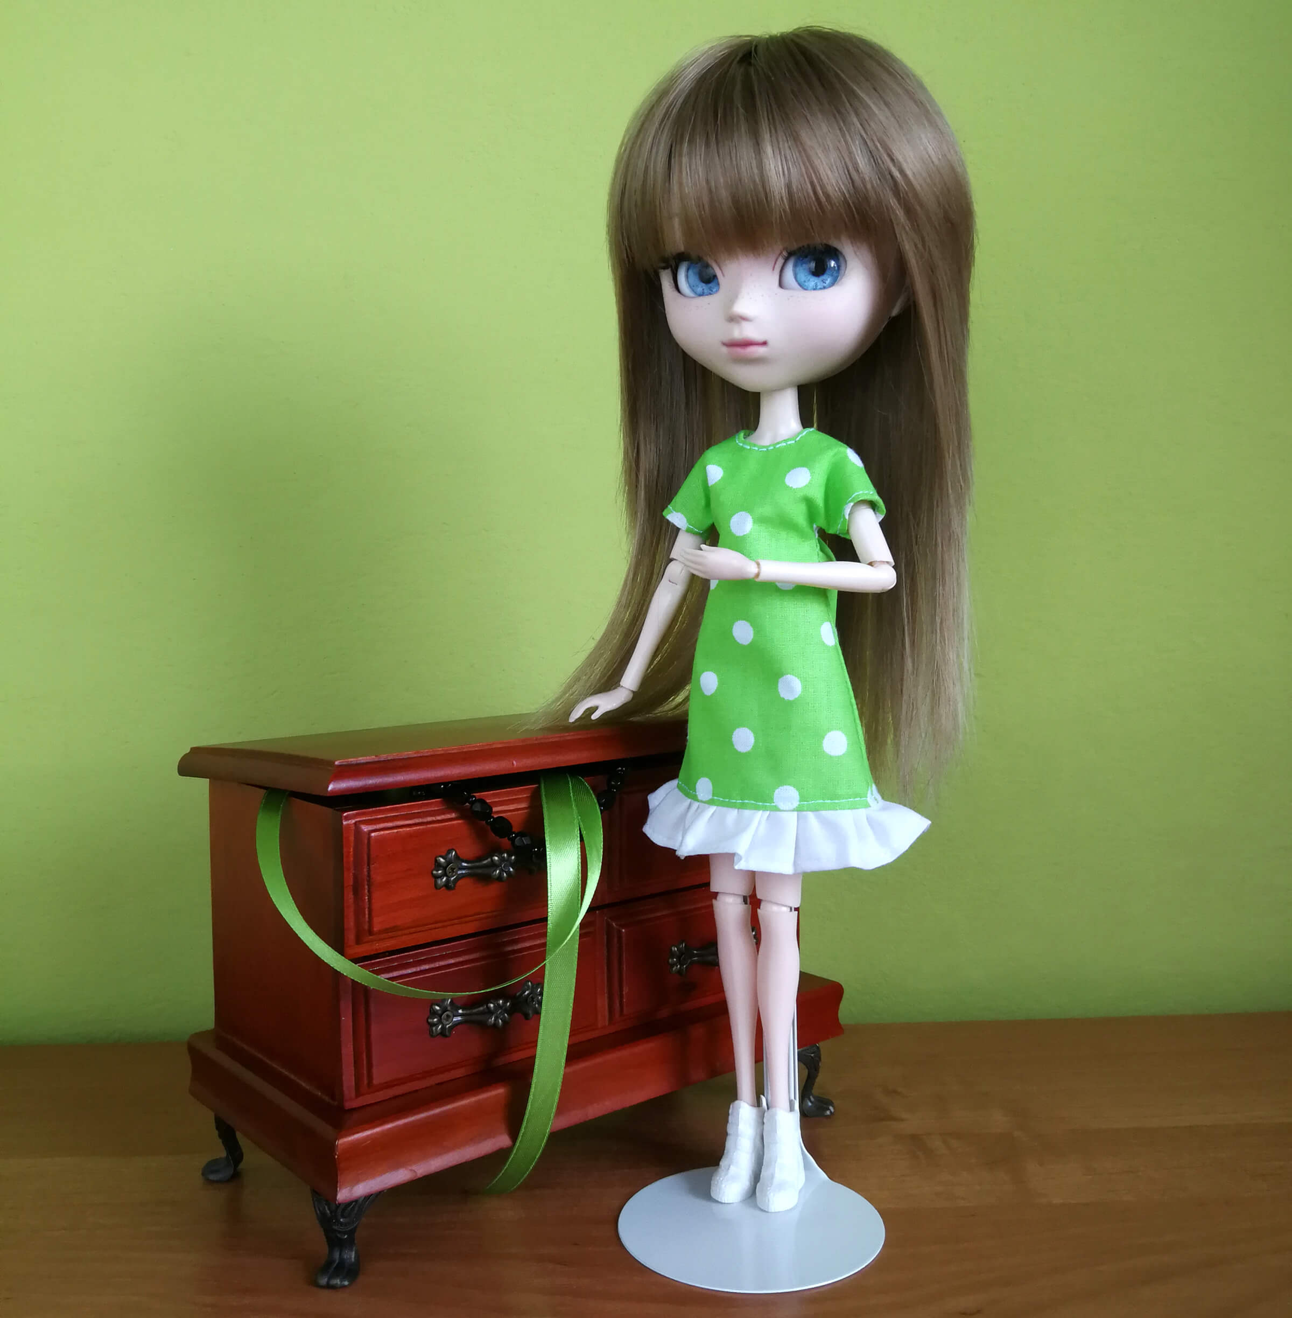
How to make the dress:
- Pattern preparation

- Make sure that the “Actual size” option is selected in the printer settings.
- Print the dress pattern pieces.
- Measure if the scale at the bottom is 1 cm long (if not, adjust the printer settings and print once again).
- Cut out the pattern pieces (note: the pattern pieces in the drawing do NOT have allowance – 0.5 cm should be added on the fabric for the seams, apart from the back of the dress where 0.7 cm should be added to allow for the fastening).

- Transferring the pattern pieces to the fabric

Note: the arrows on the pattern pieces show the direction of the warp in the material (the warp thread is parallel to the selvage).

- Iron the selected fabric; this is also the time for color planning if you use two colors.
- Fold the fabric in half, with the right side inside (in this way, you obtain the fold); if you have chosen two colors, fold two pieces of your fabric.
- Put the pattern pieces of the halves of the ruffle and of the front of the dress with the dashed line (‘fold’) corresponding to the fabric fold.
- Put the pattern of the back of the dress onto the fabric, with the direction of the arrow the same as the direction of the warp thread in the material.
- Transfer the pattern pieces on the fabric with the chalk or pencil.

- Cutting the elements out from the fabric

- Cut the elements out from the fabric.
- Spread the front and back parts of the dress, put the paper pattern piece on the other halves of those parts, and mark the seams appropriately.

After having cut out the elements from the fabric, you should have (image 1):
1 x the front of the dress, 2 x the back of the dress (those two parts must be mirror reflections), 1 x the ruffle.

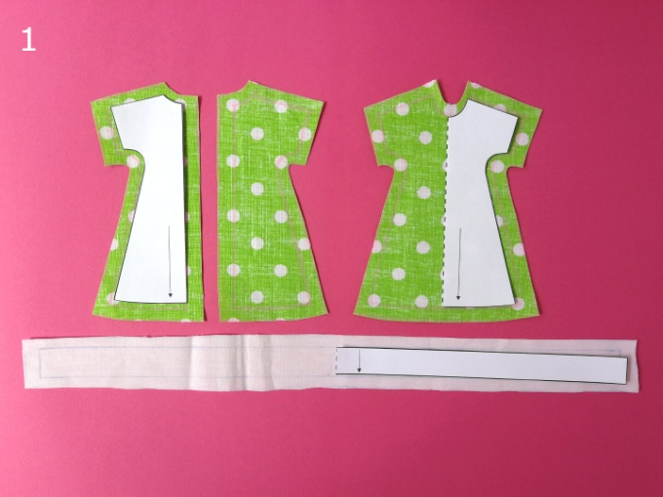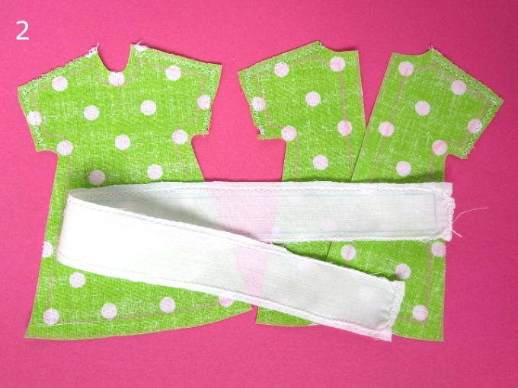
- Sewing

- Overcast all edges of the ruffle, the bottom edges of the sleeve openings, and the shoulder lines (image 2).
- Sew the elements of the dress together on the shoulders (image 3).
- Press the seams made in point 2 open.
- Fold in 0.5 cm of the bottom edges of the sleeves and topstitch them (images 4 and 5).
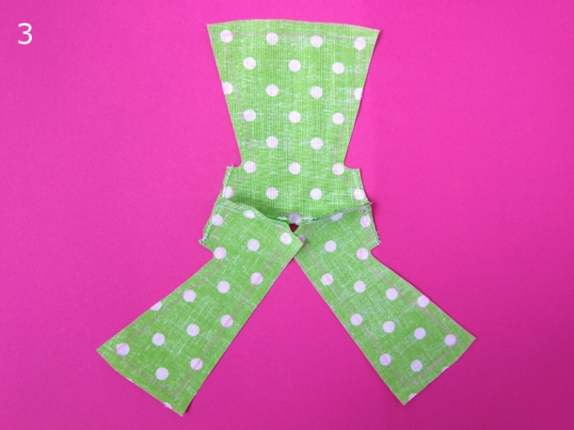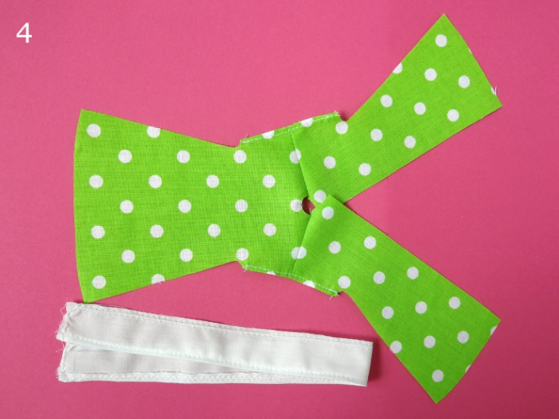
- Fold in 0.5 cm of the bottom edge of the ruffle and topstitch it (images 4 and 5).
- Overcast the neckline and the edges of the back seam of the dress (image 6).
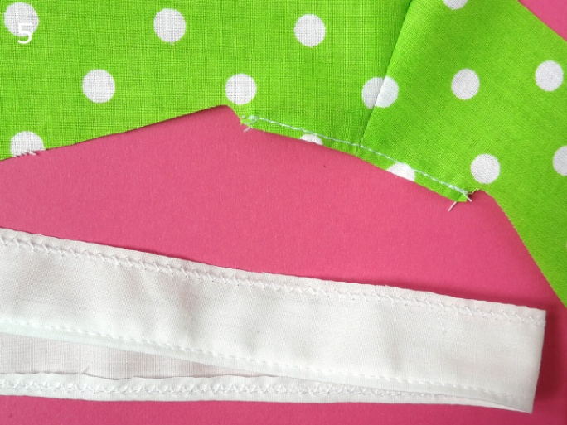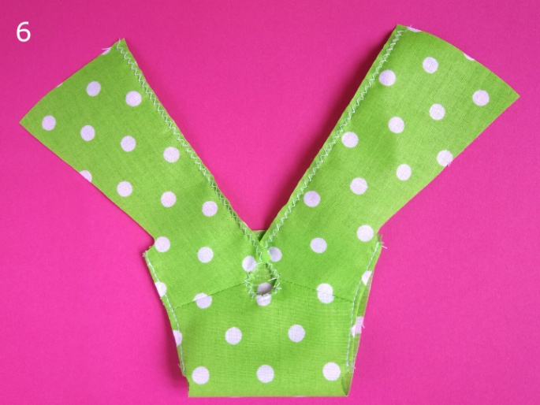
- Fold in 0.5 cm of the neckline and topstitch it (image 7).
- Sew the side edges of the dress together on the wrong side (images 8 and 9).
- Overcast the seams done in point 8 and the bottom edge of the dress (images 8 and 9).
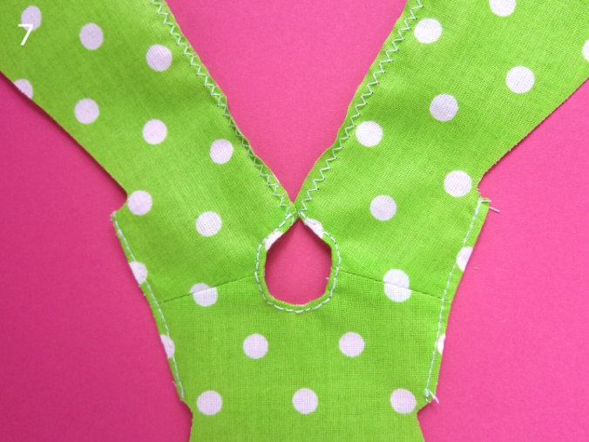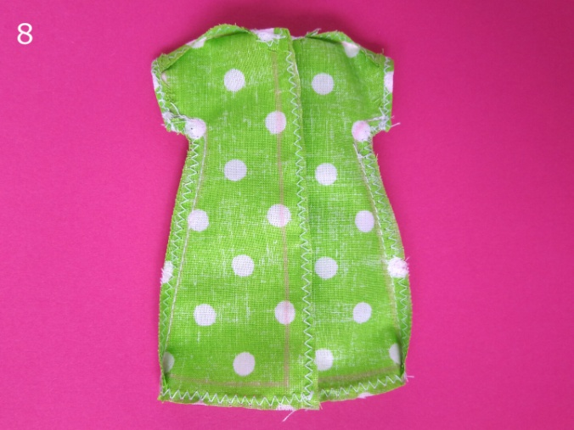
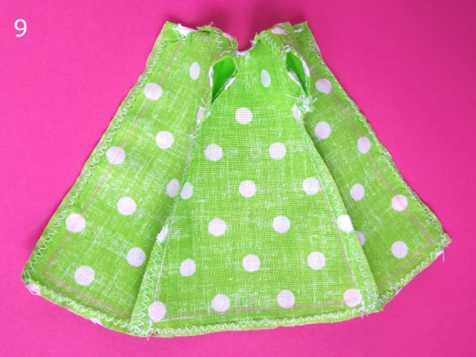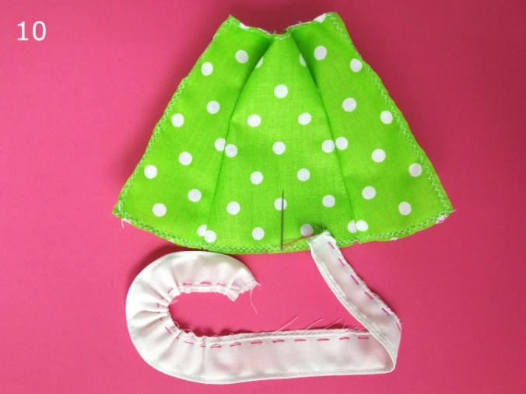

- Baste the top edge of the ruffle and leave some thread (a few centimeters), untied, on one side (image 10).
- Holding that thread, gently move the fabric so as to wrinkle the top edge of the ruffle until its length is the same as the length of the bottom edge of the dress; tie the thread so as to stabilize the ruffle (images 10 and 11).
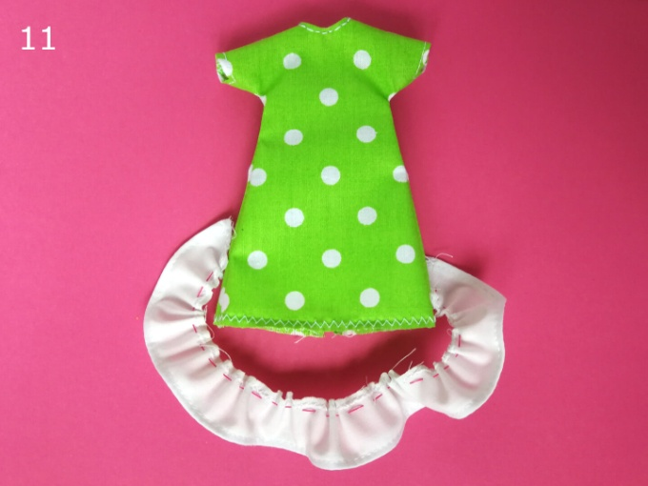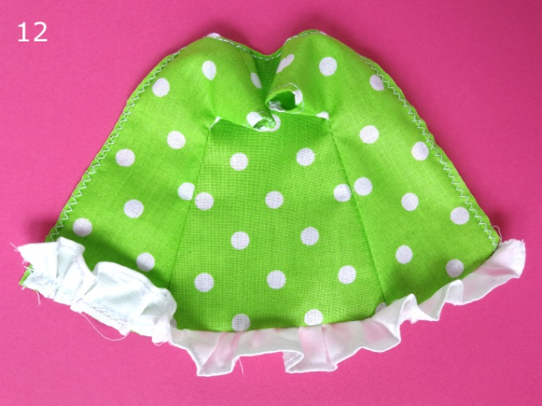
- Put the wrinkled edge of the ruffle with the right side to the right side of the bottom edge of the dress and sew the two parts together (image 12).
- Remove the basting stitches (made in point 10).
- On the right side of the dress, topstitch on the seam which joins the ruffle with the dress, at the distance of 1 mm from the edge (images 13 and 14).

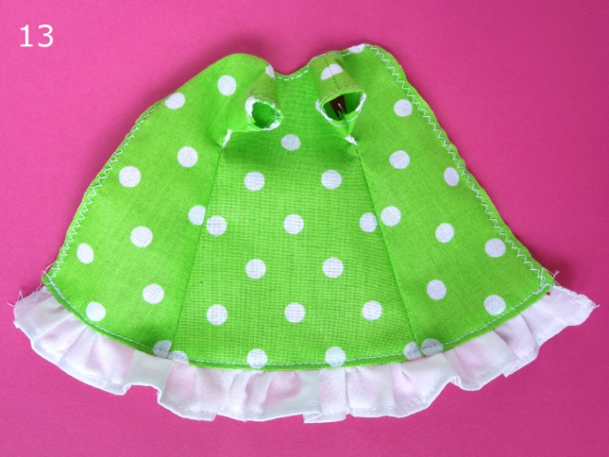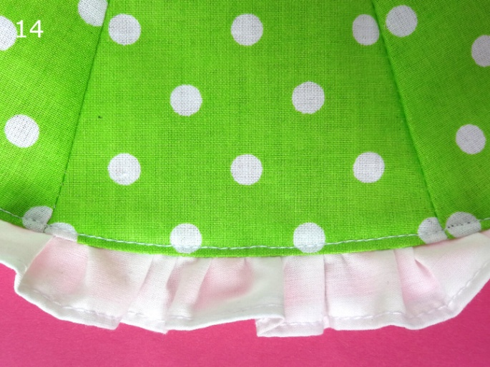

- Sew the dress together at the back, from the bottom to the place reserved for the fastening (image 15).
- Dress a doll and check if the dress fits; if it is too loose, you can sew the back seam tighter together.
- Topstitch the edge of the fastening at the back of the dress (image 16).
- Sew the fastening (velcro or snaps) at the back of the dress.
The loose waist summer dress with a ruffle is ready!
