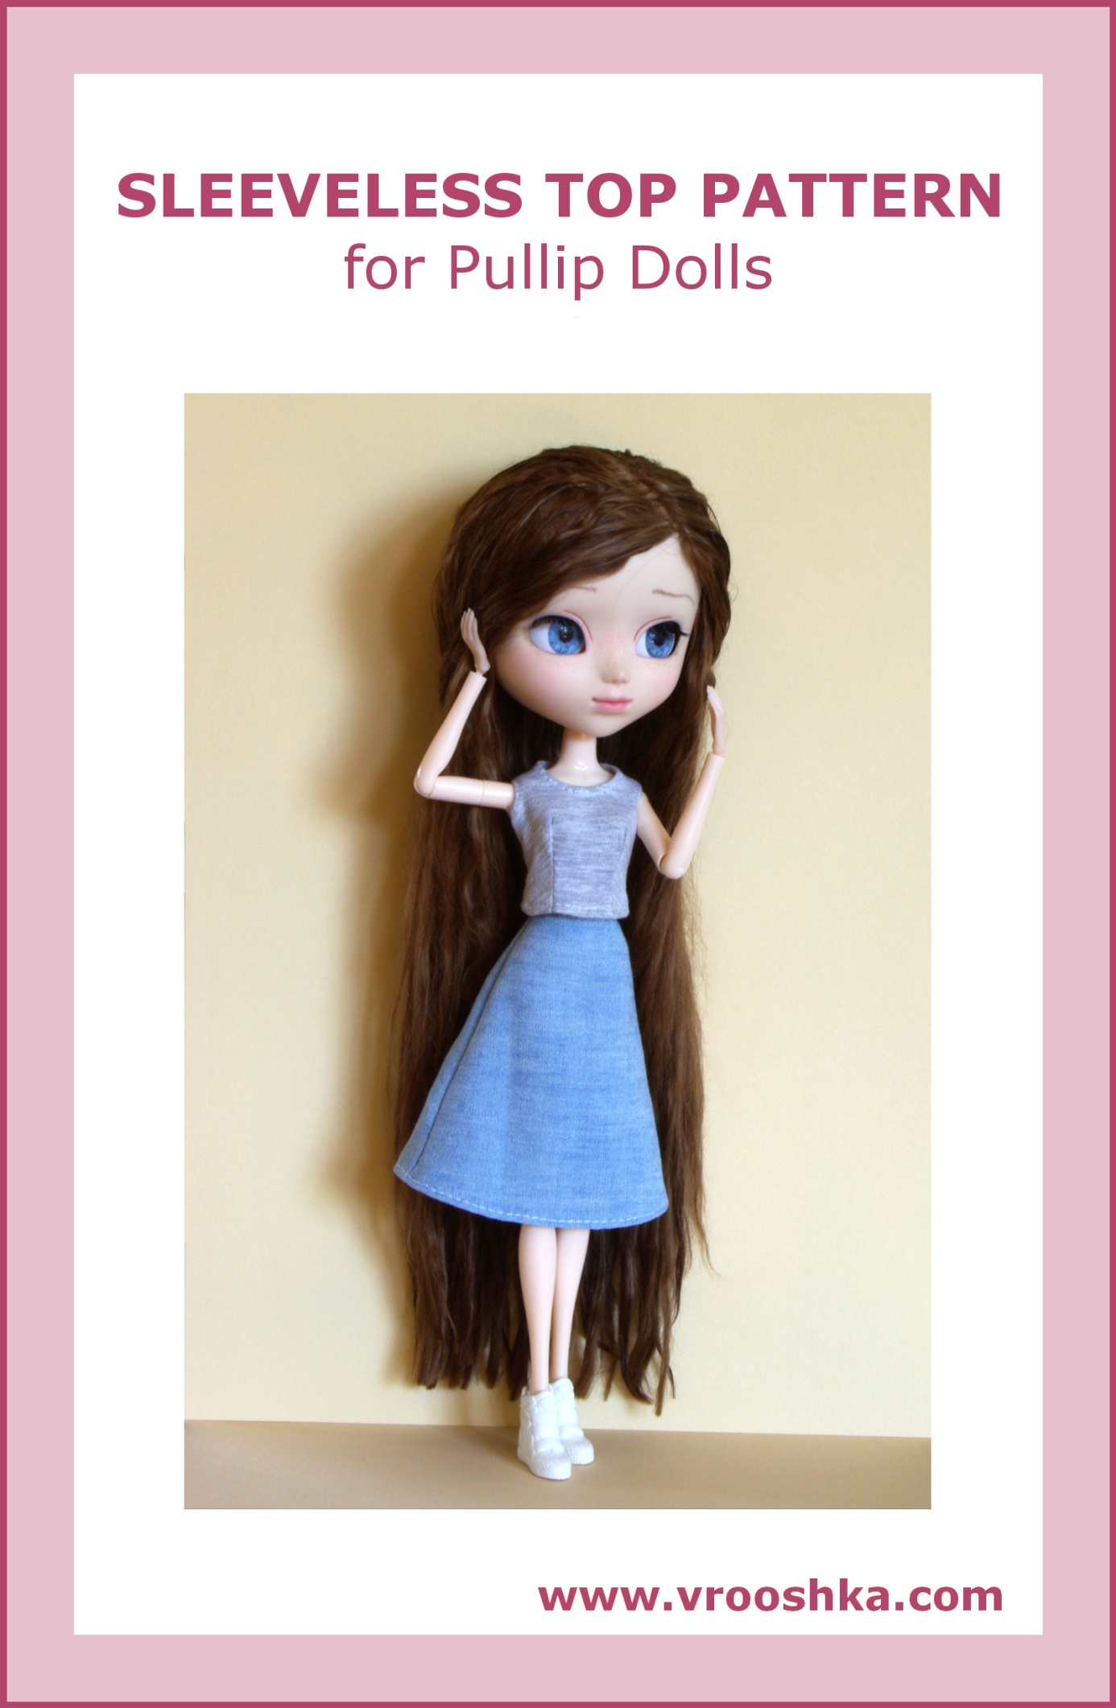
SLEEVELESS TOP

Materials:

a printer, paper, thin fabric appropriate for a sleeveless top, a narrow hook and loop fastener or three snap fasteners, a tailor’s chalk or a fabric pencil, threads and a needle or a sewing machine

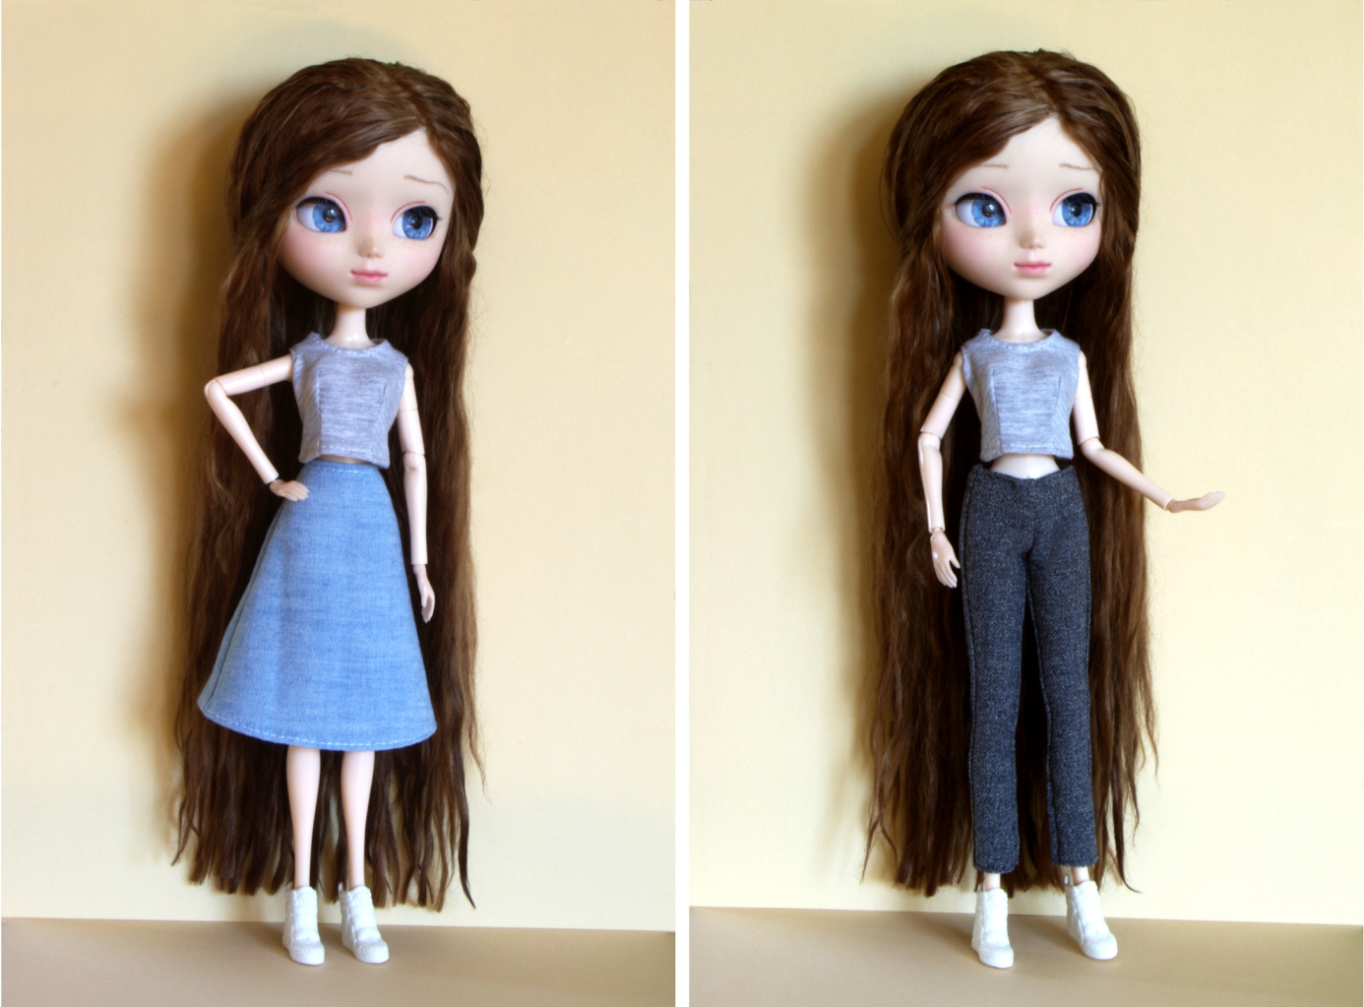

How to make the top:
- Pattern preparation

- Make sure that the “Actual size” option is selected in the printer settings.
- Print the dress pattern.
- Measure if the scale at the bottom is 1 cm long (if not, adjust the printer settings and print once again).
- Cut out the pattern (note: the pattern in the drawing does NOT have allowance: 0.5 cm should be added on the fabric for the seams, as shown in the pictures).

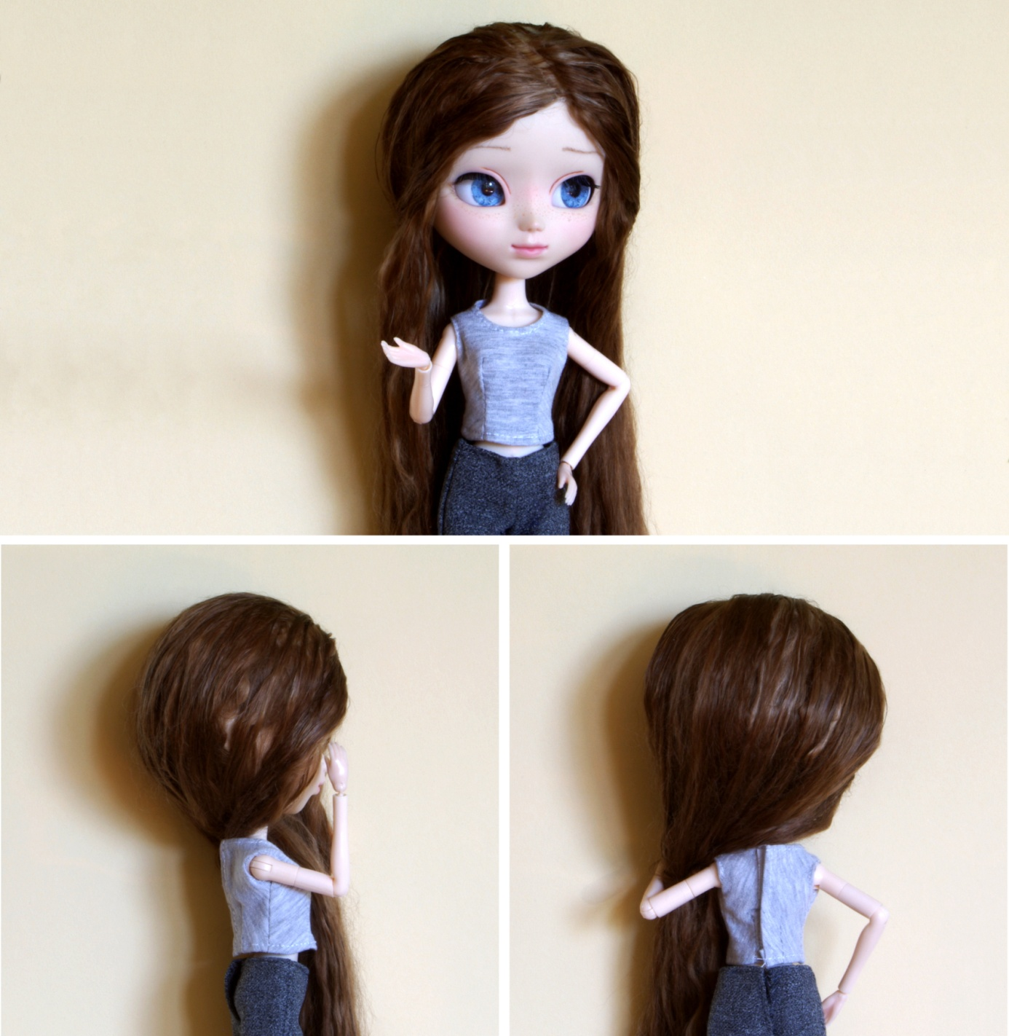

- Transferring the pattern to fabric

Note: the arrows on the patterns show the direction of the warp in the material (the warp thread is parallel to the selvage).

- Iron the selected fabric.
- Fold the fabric in half with the right side inside (in this way, you will obtain the fold).
- Put the pattern of a half of the top onto the fabric, with the dashed line (“fold”) corresponding to the fabric fold.
- Transfer the pattern on the fabric with the chalk or pencil, marking all darts (for that purpose, to make drawing easier, you can cut out the darts from the paper patterns, just remember NOT to cut them out from the fabric!).
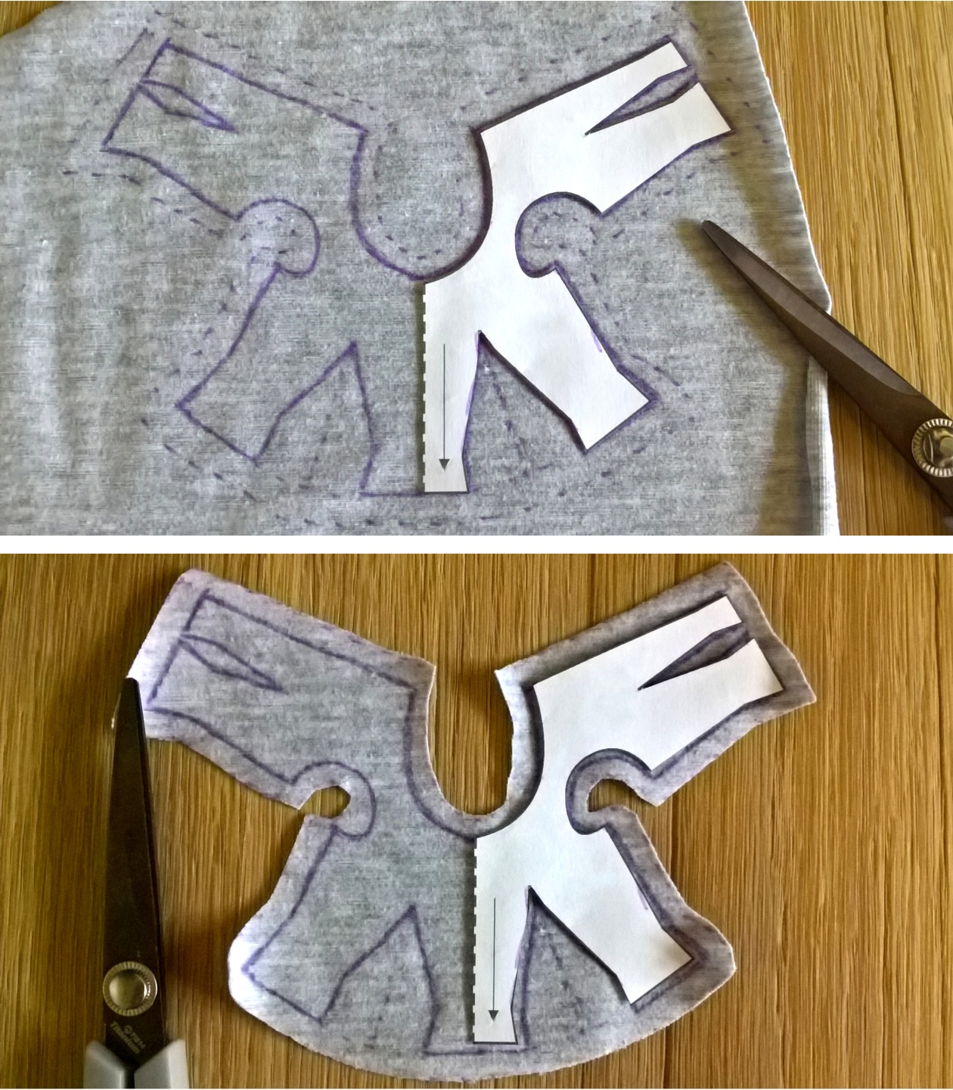
- Cutting the elements out from the fabric

- Cut the element out from the fabric (remember NOT to cut out the darts).
- Spread the top, put the paper pattern on the other half of it, and mark the darts appropriately.

After having cut out the pattern from the fabric, you should have: 1 x the whole top.

- Sewing

- On the wrong side of the front and the back of the top, sew all darts together (2 darts on the front, on the waistline, and 2 darts on the back, on the waistline).
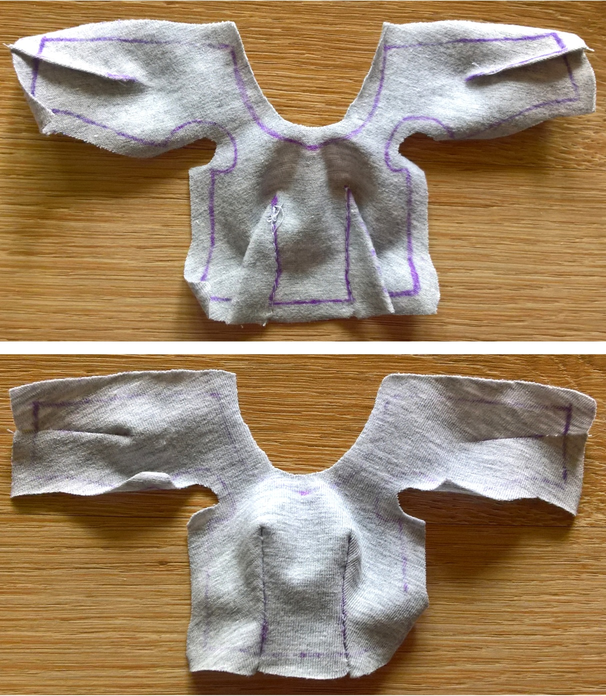
- Overcast the side edges, bottom edge, and back seam of the top (we have used jersey which does not require edge overcasting).
- Fold in 0.5 cm of the upper part – that is, of the neckline and armscye lines – once and topstitch on the right side.
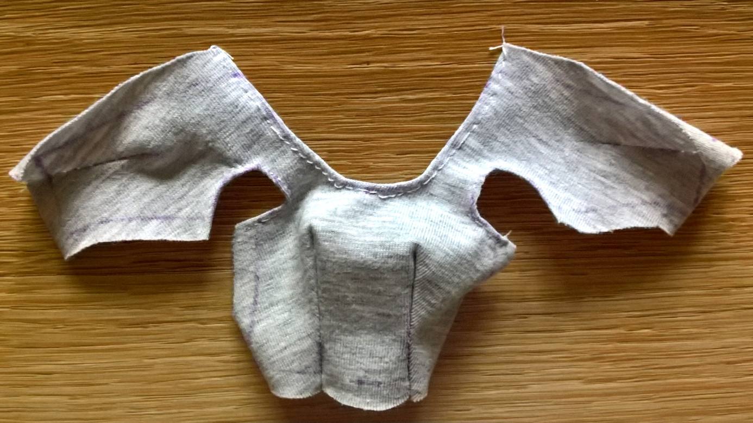
- Sew the side edges of the top together, on the left side.
- Dress a doll and check if the top fits; if it is too loose, you can sew appropriate darts tighter together or tighten the side seams.
- Fold in 0.5 cm of the bottom of the top once and topstitch.
- Fold in 0.5 cm of the edges of the opening at the back once and topstitch on the right side.
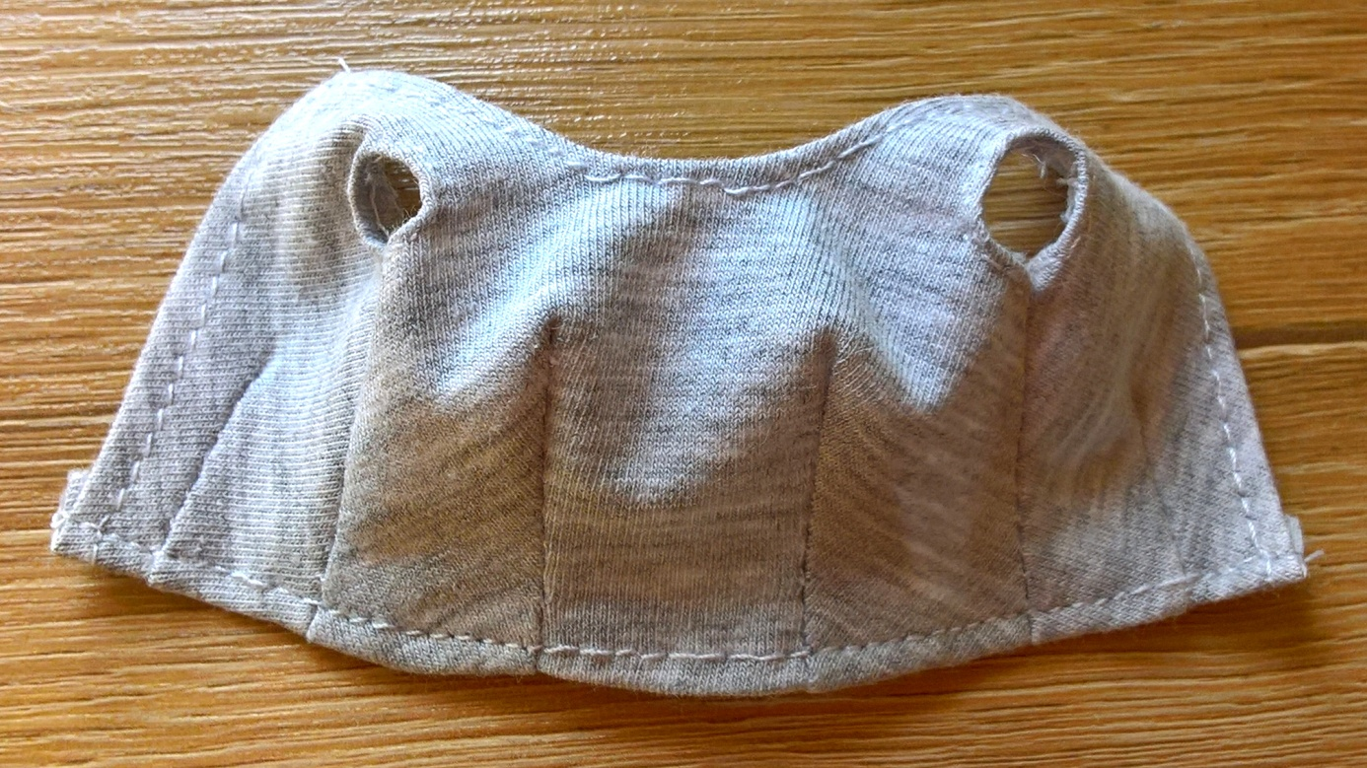
- Sew the fastening (velcro or snaps) at the back of the top.

The top is ready!
