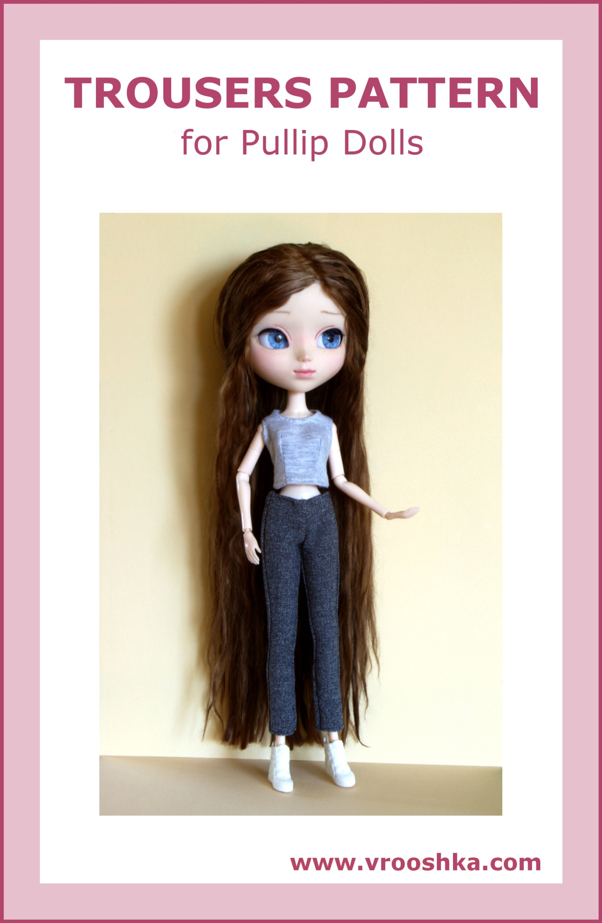
TROUSERS

Materials:

a printer, paper, fabric appropriate for trousers, a narrow hook and loop fastener or a snap fasteners, a tailor’s chalk or a fabric pencil, threads and a needle or a sewing machine

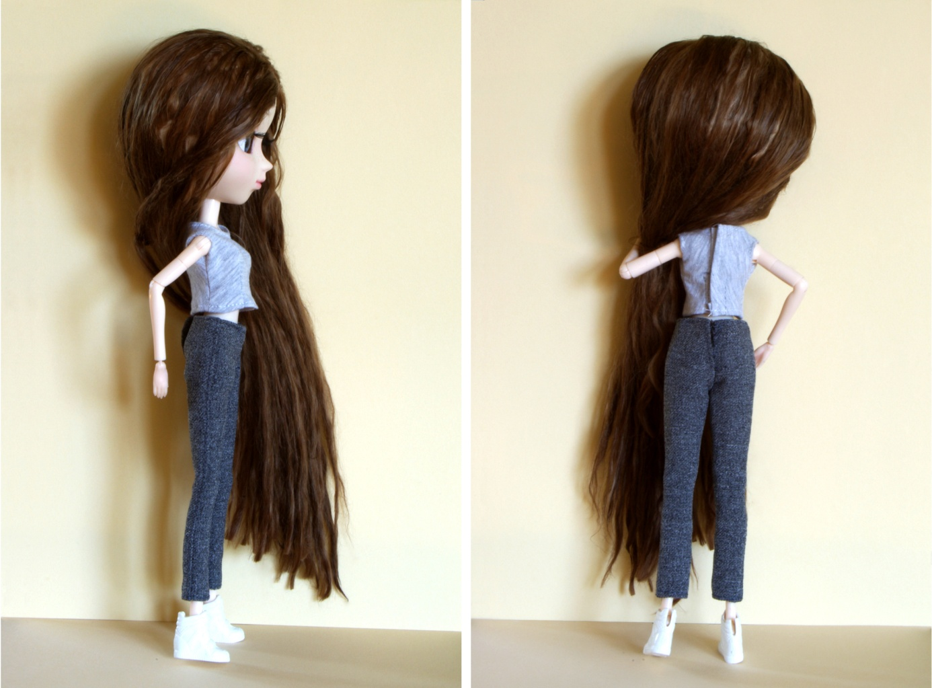

How to make the trousers:
- Pattern preparation

- Make sure that the “Actual size” option is selected in the printer settings.
- Print the trousers patterns.
- Measure if the scale at the bottom is 1 cm long (if not, adjust the printer settings and print once again).
- Cut out the patterns (note: the patterns in the drawing do NOT have allowance: 0.5 cm should be added on the fabric for the seams, as shown in the pictures).

- Transferring the patterns to fabric

Note: the arrows on the patterns show the direction of the warp in the material (the warp thread is parallel to the selvage).

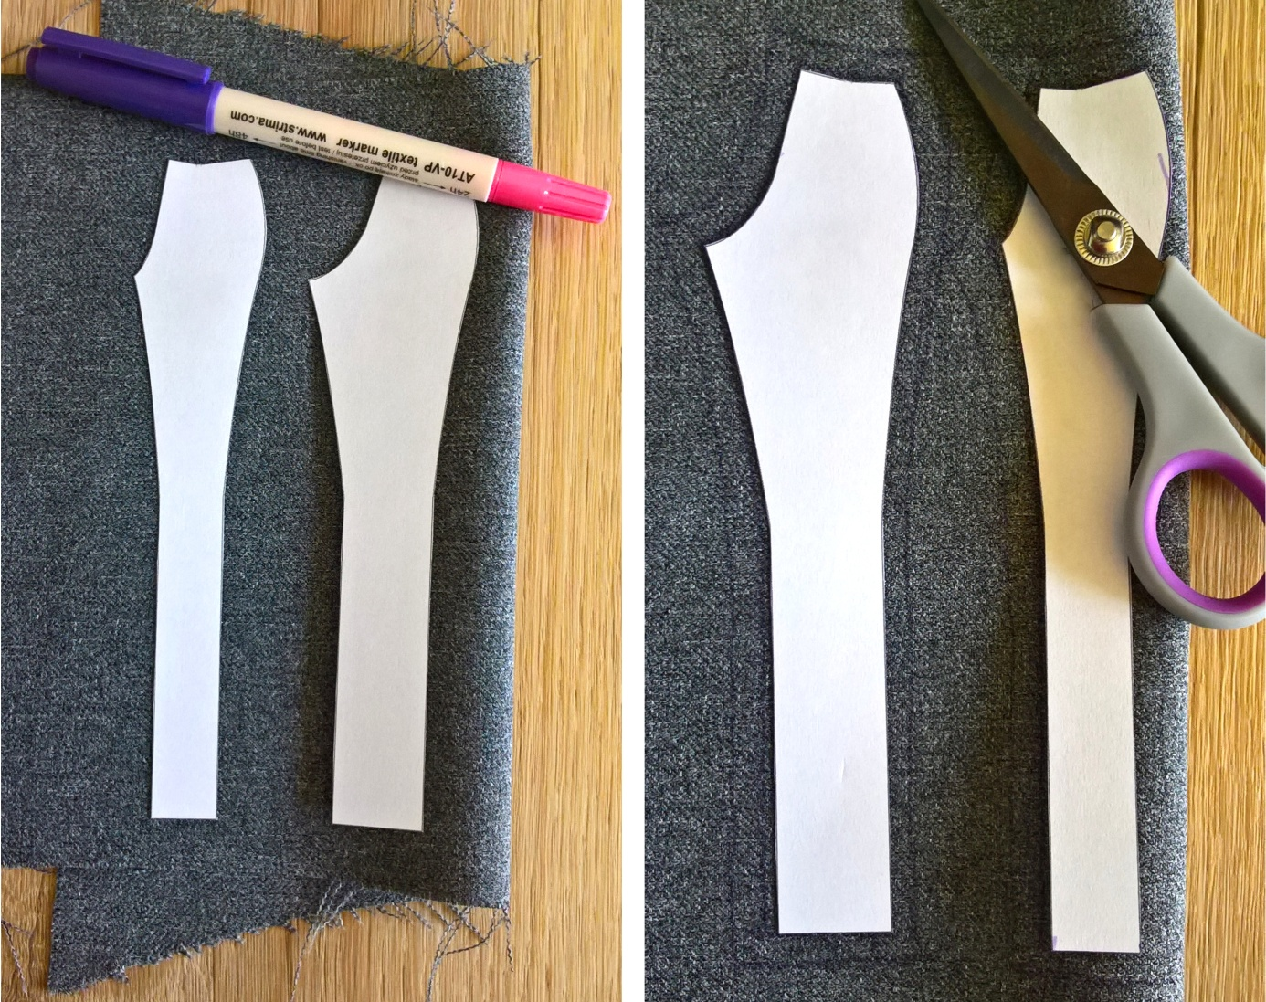

- Iron the selected fabric.
- Fold the fabric in half with the right side inside (in this way, you will obtain the fold).
- Put the pattern of the front leg of the trousers onto the fabric, with the direction of the arrow the same as the direction of the warp thread in the material.
- Put the pattern of the back leg of the trousers onto the fabric, with the direction of the arrow the same as the direction of the warp thread in the material.
- Transfer the patterns on the fabric with the chalk or pencil, and add the 0.5 allowance for the seams around the whole pattern.

- Cutting the elements out from the fabric

- Cut the elements out from the fabric.
- Spread the two front legs which have been cut out of the fabric, put the paper pattern on the second front leg and mark the allowance for the seams appropriately.
- Do the same with the second back leg of the trousers.

After having cut out the patterns from the fabric, you should have:
2 x front leg of the trousers (those two parts must be mirror reflections), 2 x back leg of the trousers (those two parts must be mirror reflections).
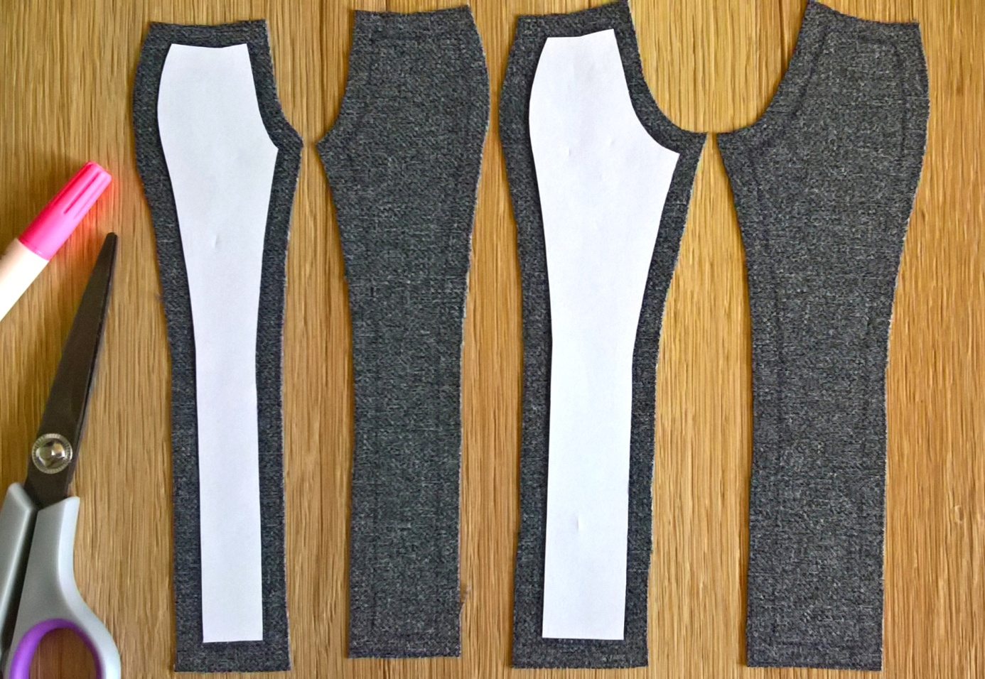
- Sewing

- Overcast all edges of the elements cut out of the material.
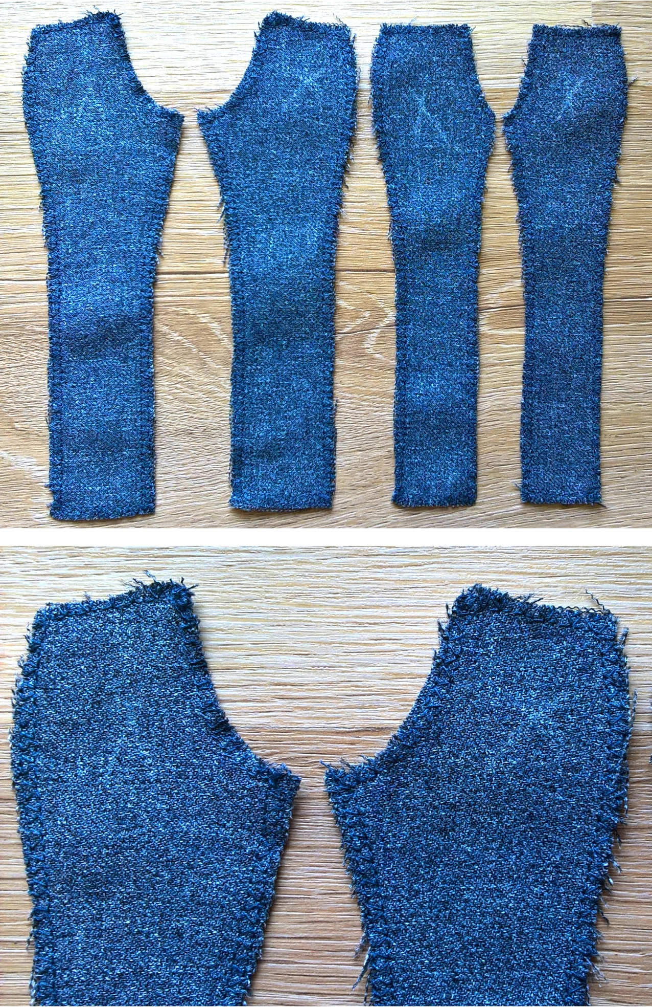
- Sew the edges of the trousers on the left side, along the outer edges of the legs: the right front leg to the right left leg, the left front leg to the left back leg.
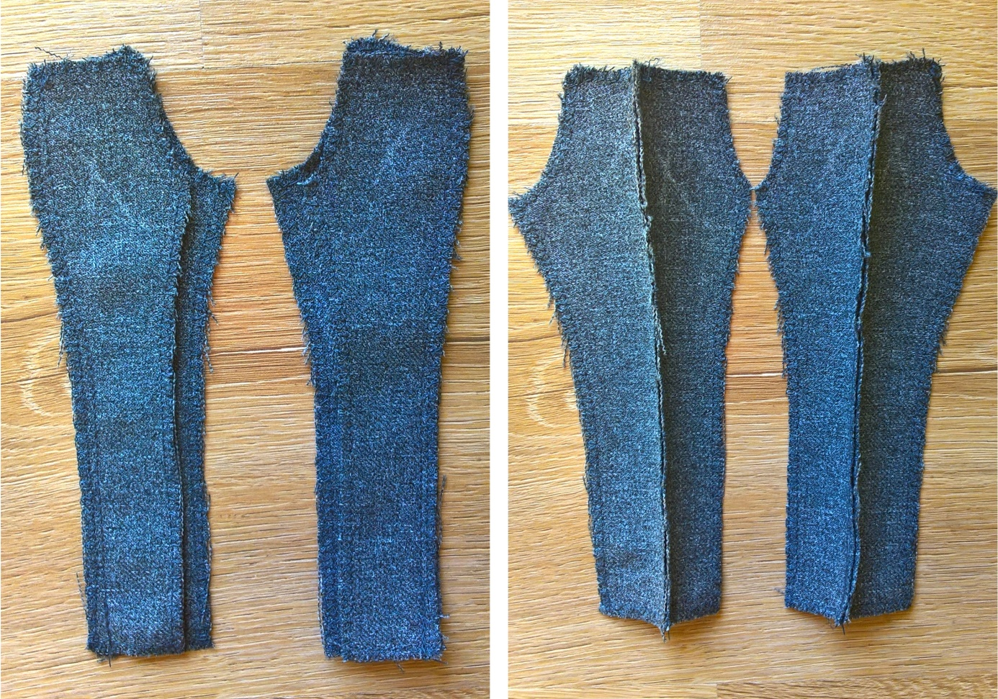
- Iron the side seams of the trousers.
- On the right side, topstitch the side seams of the trousers (this is optional – topstitching is decorative here).
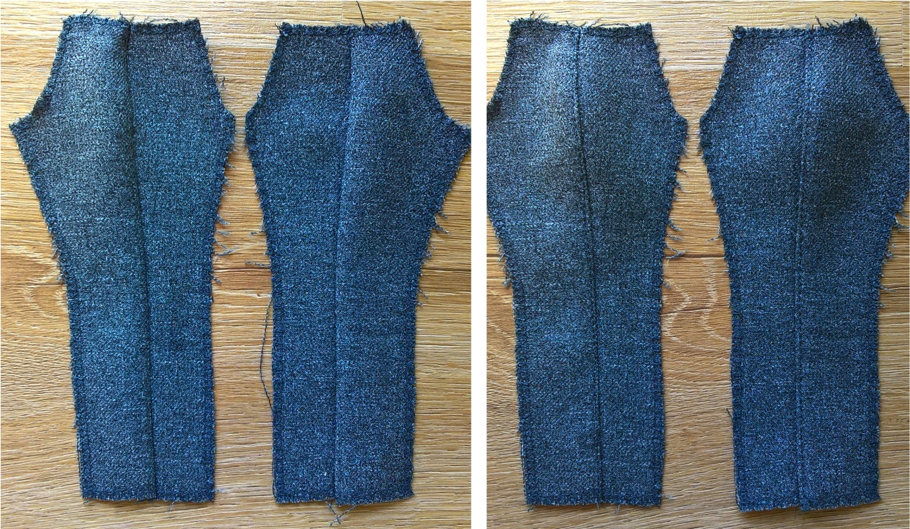
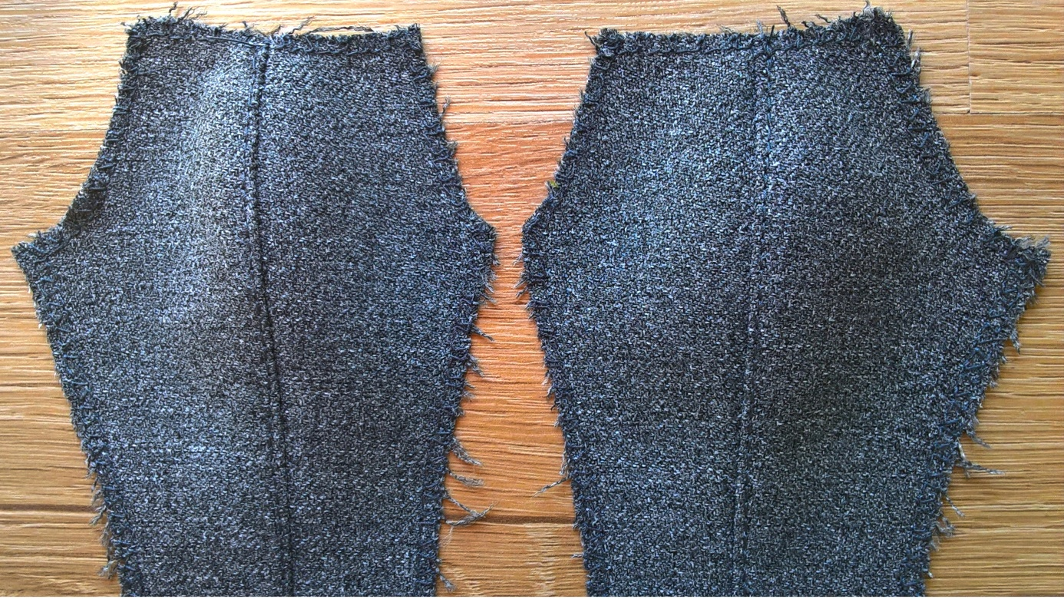
- Put the two parts of the trousers, prepared in that way, together, with the right side inside.
- Sew the two front legs together, on the left side, along the middle line and front crotch line.
- Sew the two back legs together, on the left side, along the middle line and back crotch line, leaving an unsewn section for the fastening.
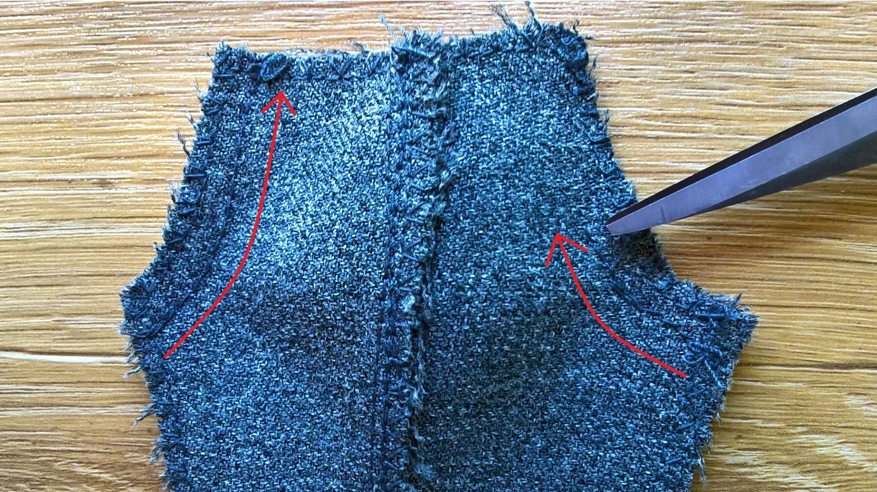
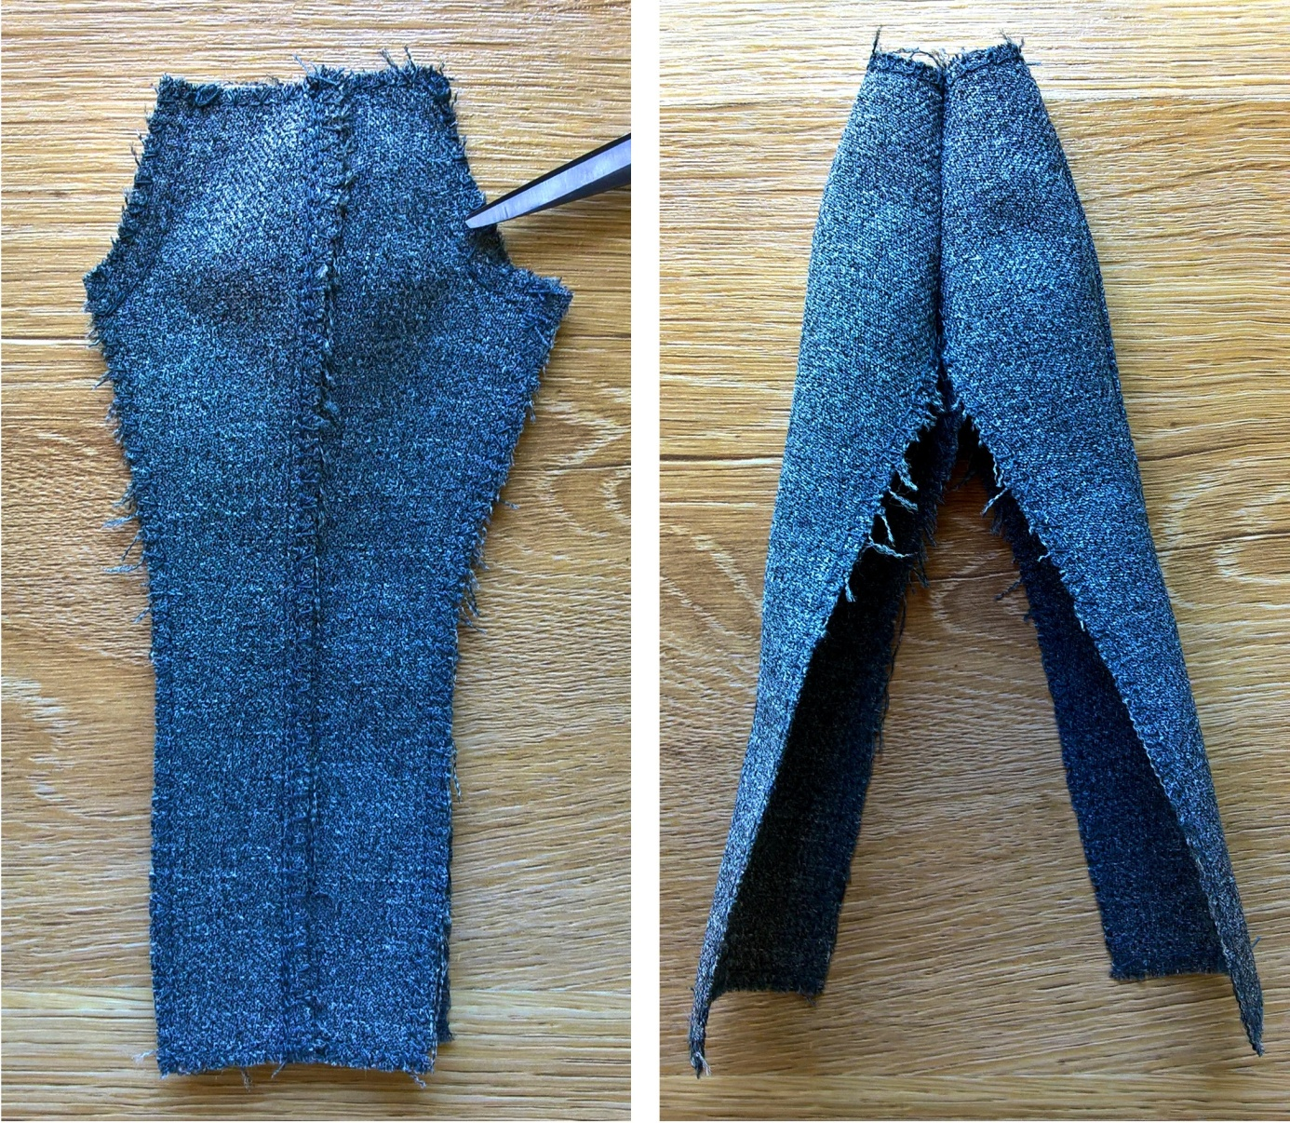
- Dress a doll and check if the trousers fit, especially if they can be put on the dolls hips; if they are too lose, you can sew the trousers tighter together along the crotch line or tighten the side seams.
- Sew the inner edges of the trouser legs together, on the left side.
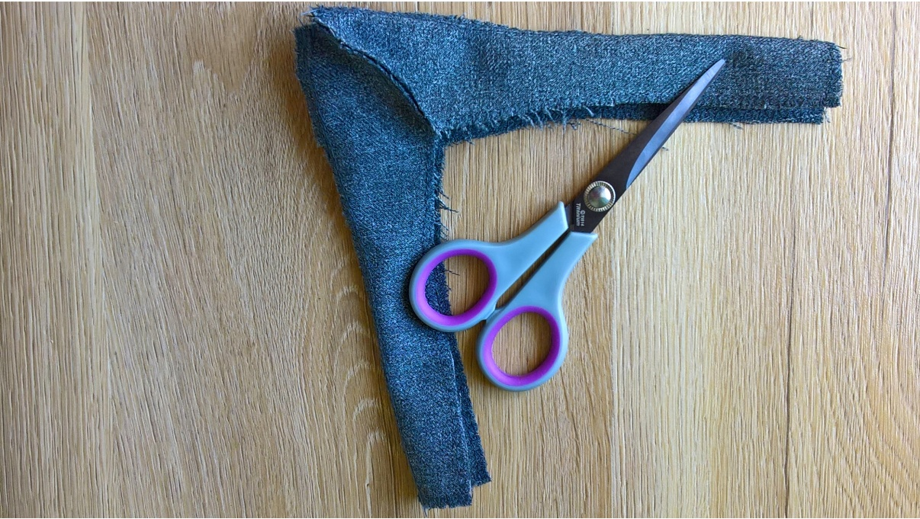
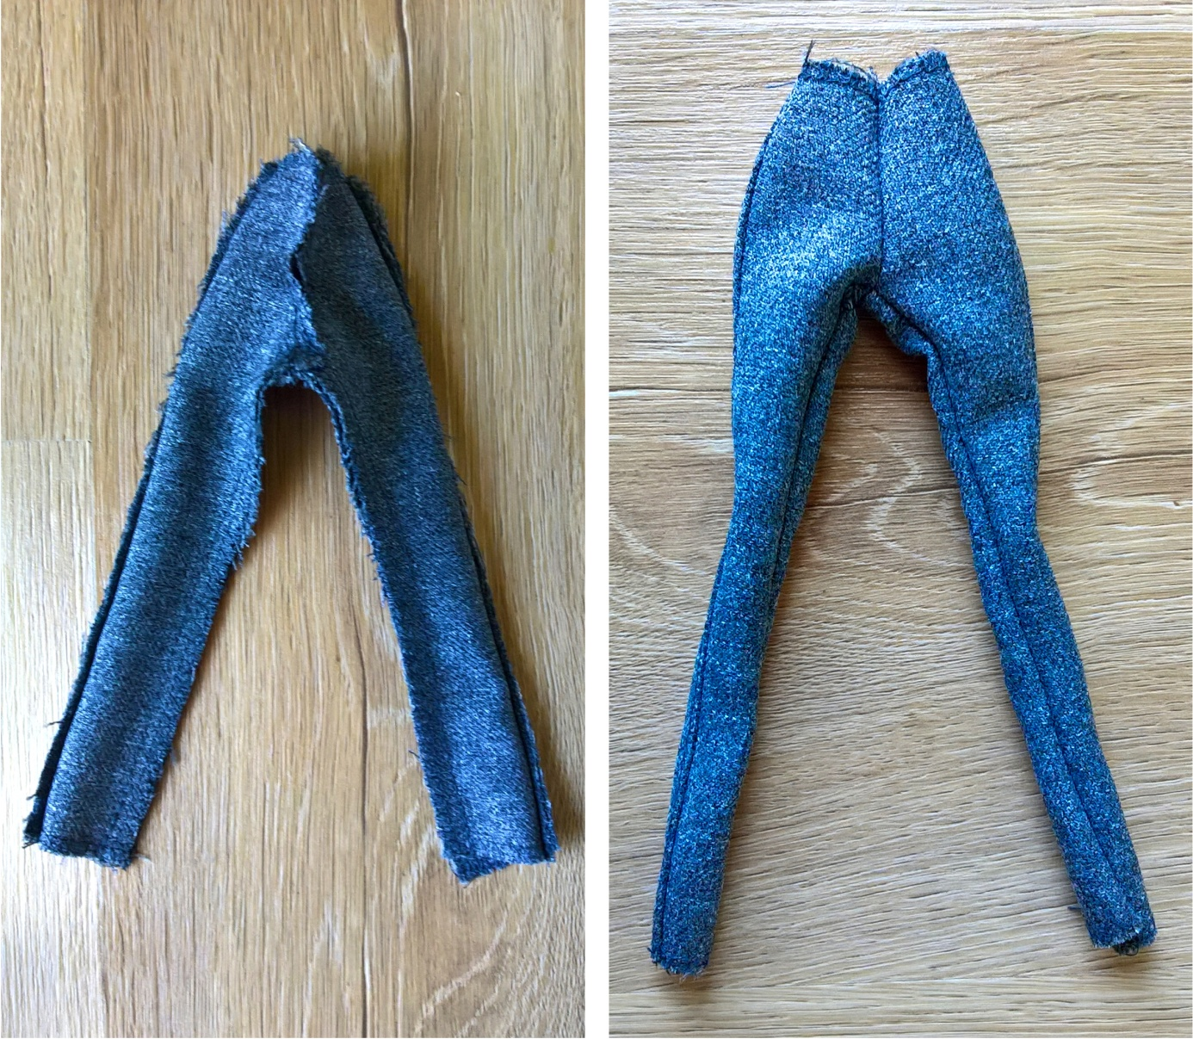
- Turn the trousers inside out, to the right side, and dress the doll again; if they are too loose, you can sew the inner leg sides tighter together.
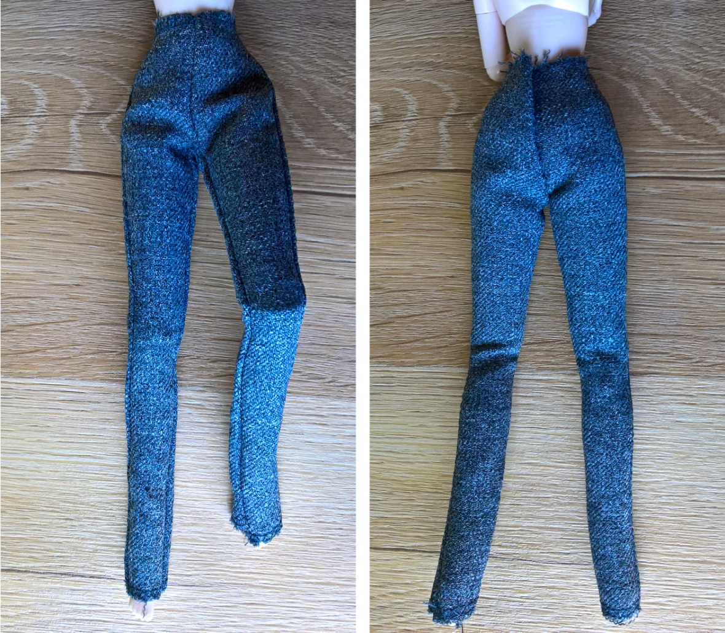
- Fold 0.5 cm of the top of the trousers in once and topstitch.
- Fold 0.5 cm of the bottom of the trouser legs in once and topstitch.
- Sew the fastening (velcro or a snap) at the back of the trousers.
The trousers are ready!