
KIMONO SLEEVE DRESS

Materials:

a printer, paper, knitted fabric – e.g. jersey, a tailor’s chalk or a fabric pencil, threads and a needle or a sewing machine

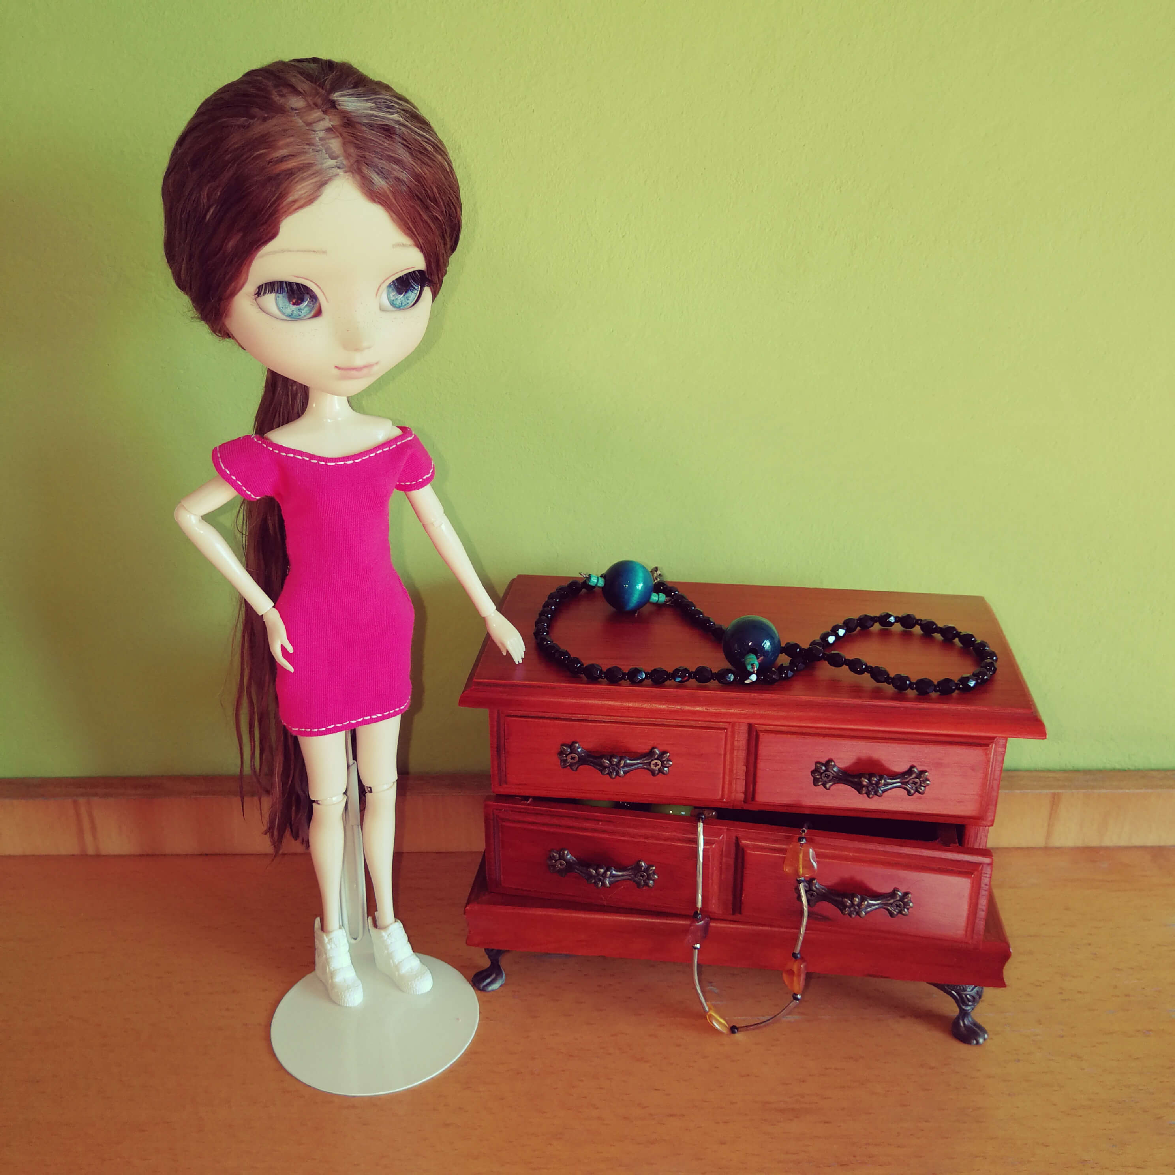
How to make the kimono sleeve dress:
- Pattern preparation

- Make sure that the “Actual size” option is selected in the printer settings.
- Print the dress patterns.
- Measure if the scale at the bottom is 1 cm long (if not, adjust the printer settings and print once again).

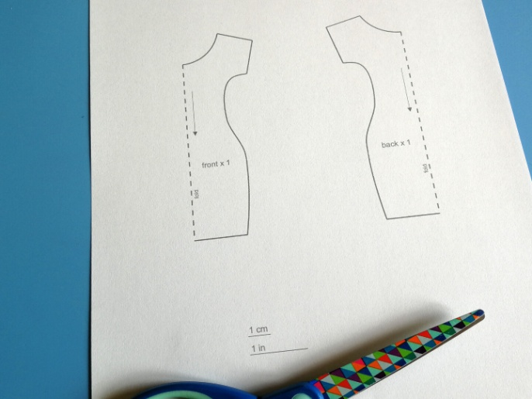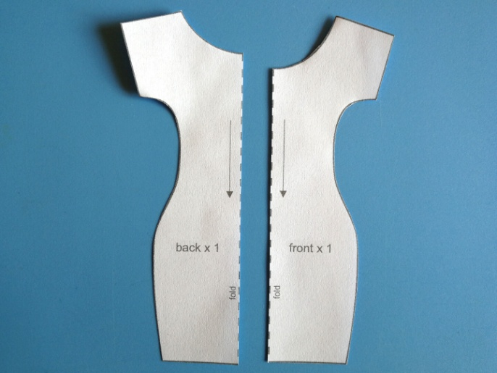

- Cut out the patterns (note: the patterns in the drawing do NOT have allowance: 0.5 cm should be added on the fabric for the seams, as shown in the pictures).

- Transferring patterns to fabric

Note: the arrows on the pattern pieces show the direction of the warp in the material (the warp thread is parallel to the selvage).

- Iron the selected fabric.
- Fold the fabric in half with the right side inside (in this way, you will obtain the fold).
- Put the pattern piece of a half of the front onto the fabric, with the dashed line (“fold”) corresponding to the fabric fold.
- Put the pattern piece of a half of the back onto the fabric, with the dashed line (“fold”) corresponding to the fabric fold.
- Transfer the pattern pieces on the fabric with the chalk or pencil.
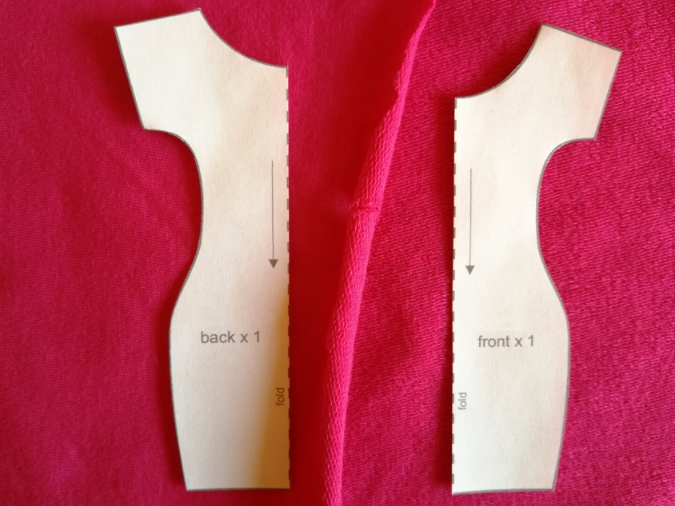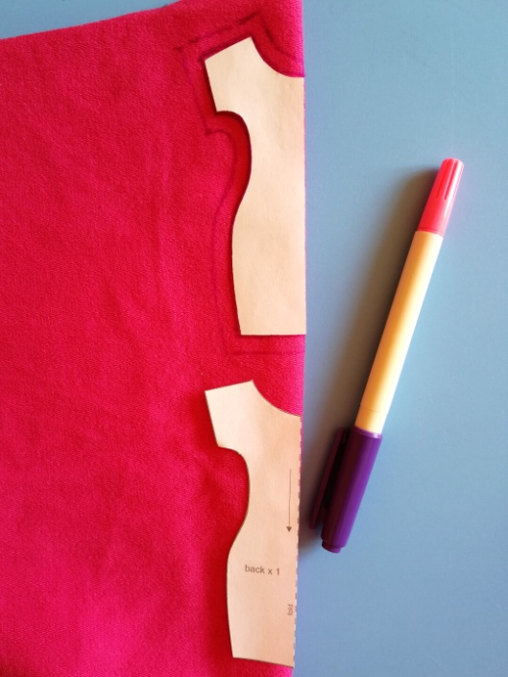

- Cutting the elements out from the fabric

- Cut the elements out from the fabric.
- Spread the front of the dress, put the pattern piece on the other half of the front, and mark the allowance for the seams appropriately.
- Do the same with the other part of the back of the dress.

After having cut out the elements from the fabric, you should have:
1 x the back of the dress, 1 x the front of the dress.

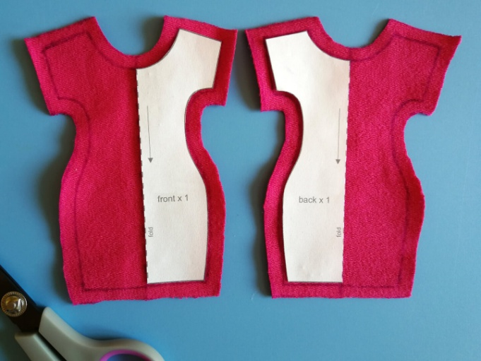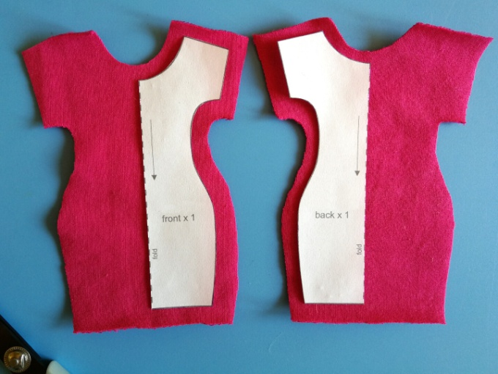

- Sewing

- Optionally, if your chosen fabric unravels at the edges or if you wish to have a more finished visual effect, overcast all edges of the front and back of the dress (many types of knitted fabric do not require edge overcasting).
- Sew the side edges of the dress together.

- Sew the elements of the dress together on the shoulders.

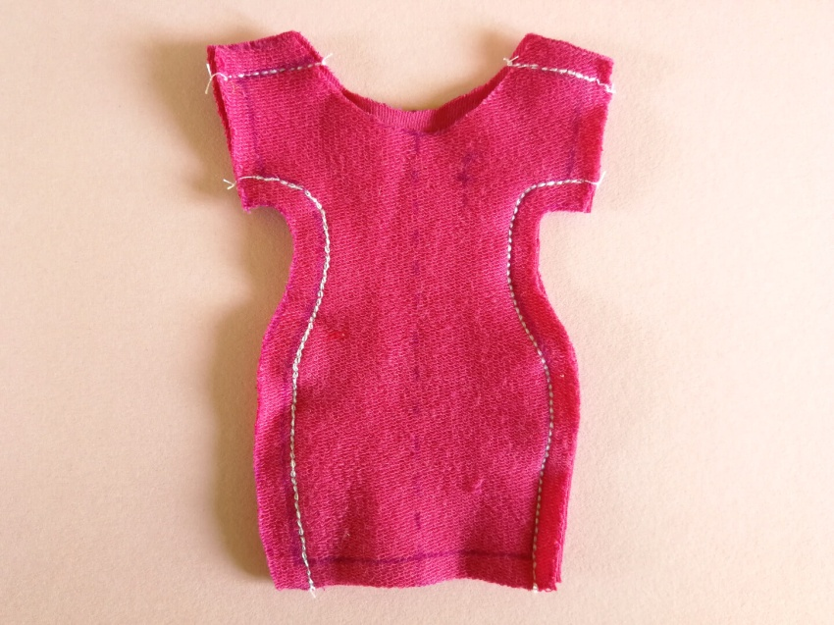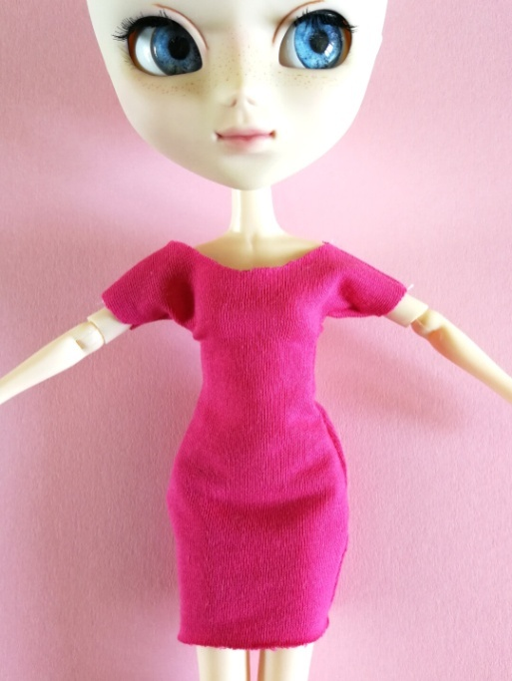

- Dress a doll and check if the dress can be put on from the bottom up (the dress does not have a fastening) and if it fits well; if it is too loose, you can tighten the side seams (carefully so that it can still put it on from the bottom up); if the cleavage is too small to put the dress on that way, you can widen it by cutting off more fabric (1 mm), and try to put the dress on again.
- Fold 0.5 cm of the bottom of the dress in once and topstitch it.
- Fold in 0.5 cm of the upper part of the dress, that is, the cleavage and the sleeve edges, and topstitch them.

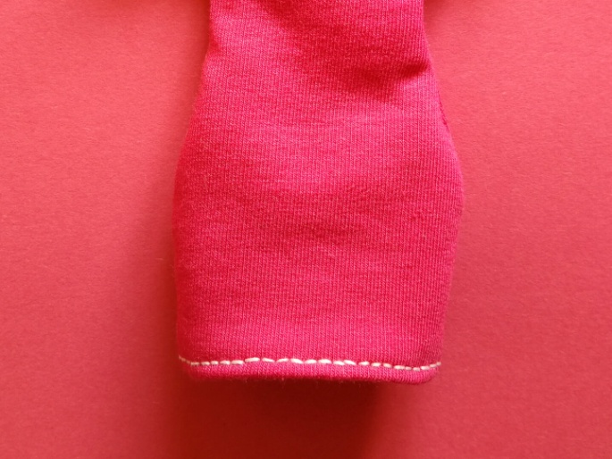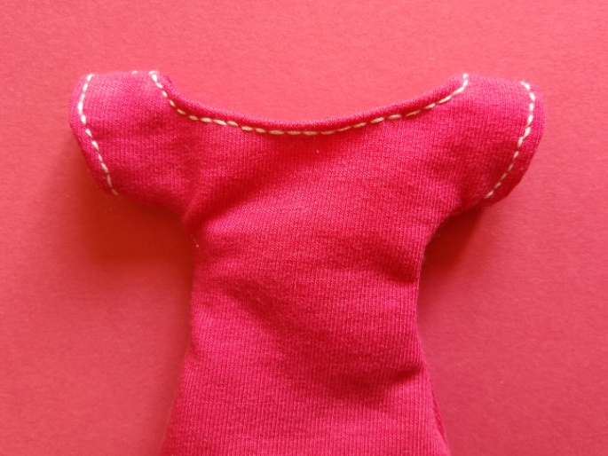
The kimono sleeve dress is ready!

