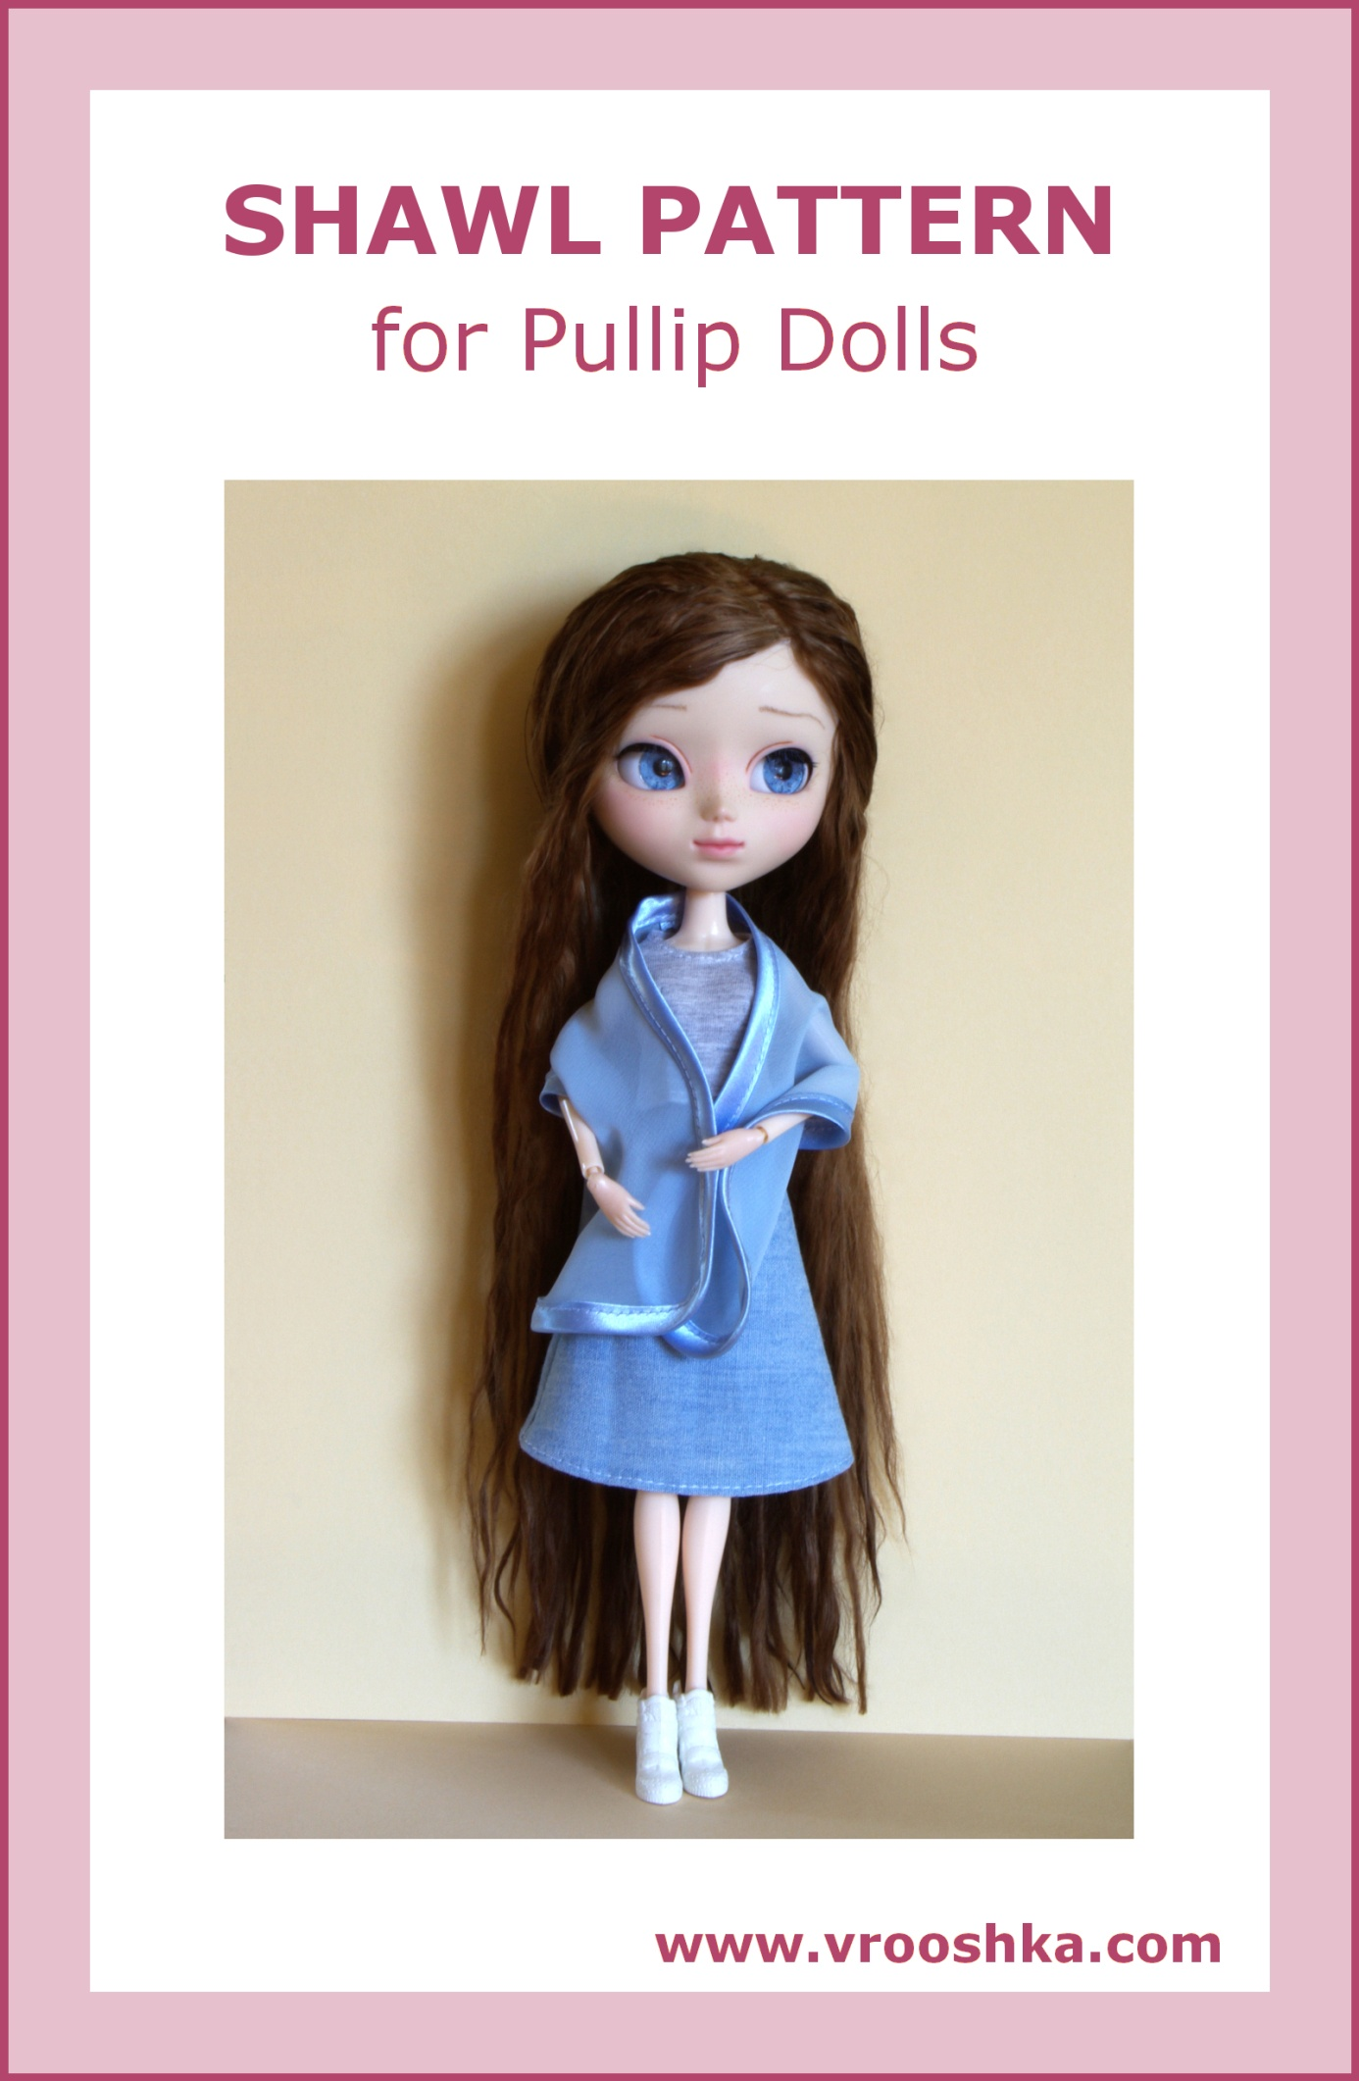
SHAWL

Materials:

a printer, paper, thin fabric appropriate for a shawl, for example, chiffon (Japanese or other type), narrow bias tape or fabric for making it, a tailor’s chalk or a fabric pencil, threads and a needle or a sewing machine

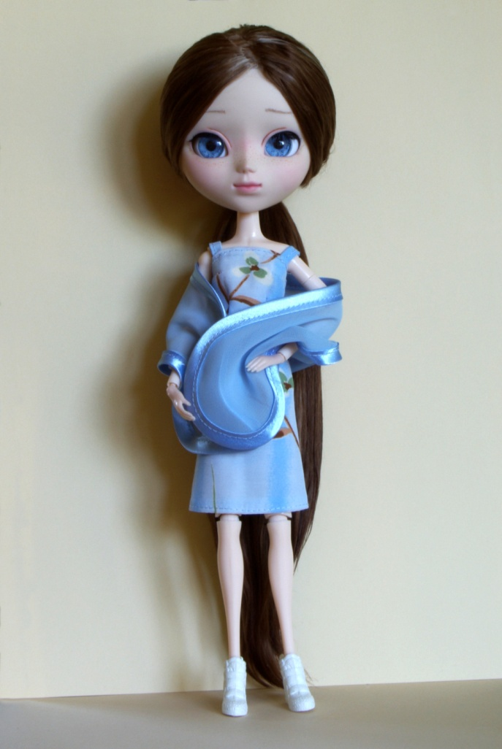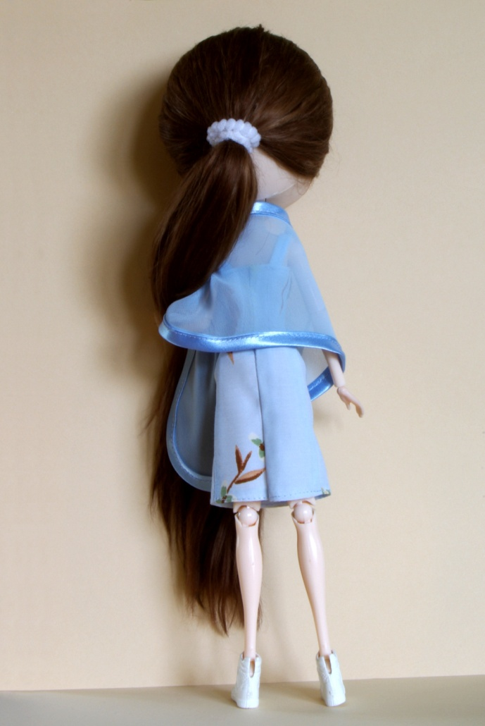

How to make the shawl:
- Print the shawl pattern (make sure that the “Actual size” option is selected in the printer settings).
- Measure if the scale in the illustration is 1 cm long (the pattern in the drawing has 0.5 cm allowance for finishing with bias tape).
- Cut out the pattern.
- Iron the fabric.
- Fold the fabric twice, with the right side inside.
- Put the pattern of the shawl onto the fabric, with the dashed line (“fold”) corresponding to the fabric fold.
- Transfer the pattern on the material with a chalk or a pencil.
- Cut the element out from the fabric.
- Finish the whole edge of the shawl with the bias tape (you can also make a bias tape yourself, preferably of the fabric that was used for the clothes worn with the shawl).
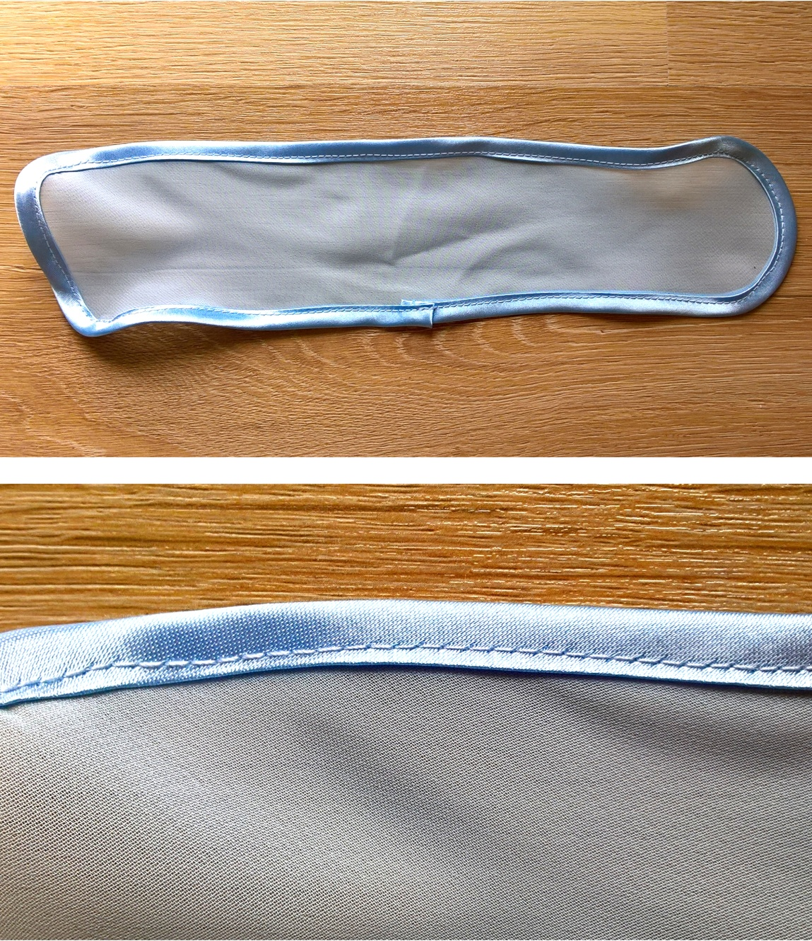
How to make a bias tape:
A bias tape is a strip of fabric cut on the bias (at 45 degrees to the selvage of the fabric), with appropriately ironed edges: to the middle, with the right side of the fabric being on the outside).

- Cut a square out from the fabric, with its edges corresponding to the direction of the fabric threads.
- Fold the square along the diagonal, open the fabric and mark the folding line.
- Draw strips parallel to the diagonal; the strips should be twice as wide as the desired width of the tape.
- Cut the strips out.
- Sew the strips together so as to obtain one long strip (particular strips should be placed at 90 degrees to each other, with the right side of the fabric inside).
- Press the seams open and trim the seam corners which stick out with scissors.
- Press the edges of the strip to the middle.
Enjoy your beautiful work!
